Assignment – 08
Select Commands
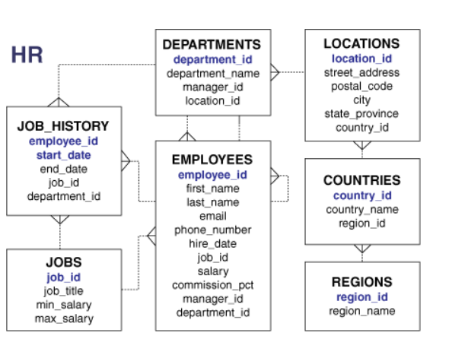

1. From the following table, return complete information about the employees.
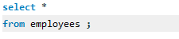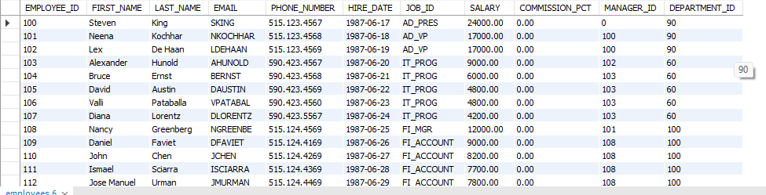

2. From the following table, write a query to find the salaries of all employees. Return salary.
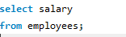
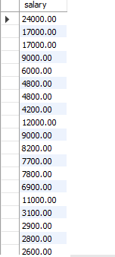

3. From the following table, write a query to find the unique designations of the employees. Return job name.
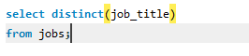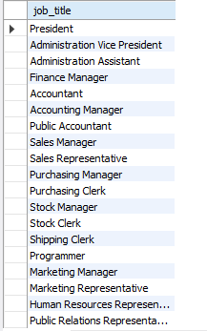

4. From the following table, write a query to list the employees’ names, increase their salary by 15%, and express the number of Dollars.
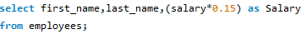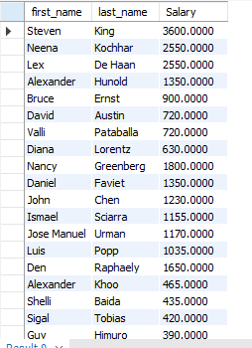
5. From the following table, write a query to list the employee's name and job name in a format of "Employee & Job".
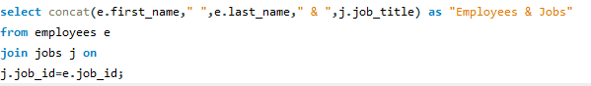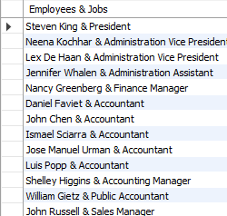
6. Write a query to produce the output of employees as follows.
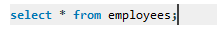

7. From the following table, write a query to find those employees with a hire date in the format of February 22, 1991. Return employee ID, employee name,
8. From the following table, write a query to count the number of characters except the spaces for each employee name. Return employee name length.
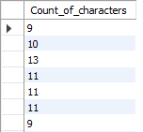
9. From the following table, write a query to find the employee ID, salary, and commission of all the employees.
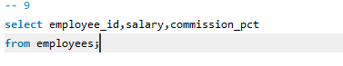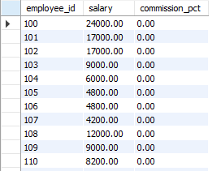
10. From the following table, write a query to find the unique department with jobs. Return department ID, Job name.
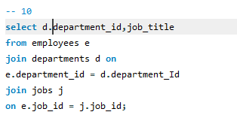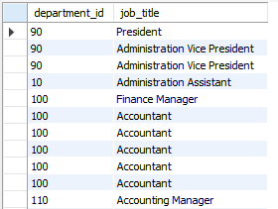
11. From the following table, write a query to find those employees who do not belong to department 90. Return complete information about the
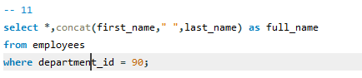
12. From the following table, write a query to find those employees who joined before 1991. Return complete information about the employees.
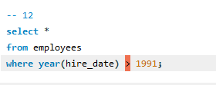
13. From the following table, write a query to calculate the average salary of employees who work as analysts. Return average salary.
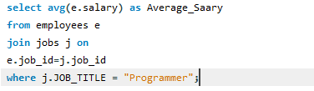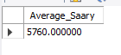
14. From the following table, write a query to find the details of the employee ‘BLAZE’.
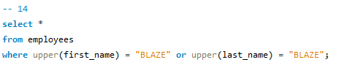
15. From the following table, write a query to identify employees whose commissions exceed their salaries. Return complete information about the employees.
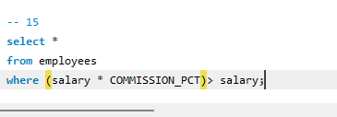
16. From the following table, write a query to identify those employees whose salaries exceed 3000 after receiving a 25% salary increase. Return complete information about the employees.
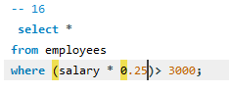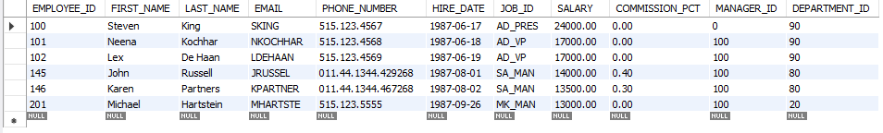
17. From the following table, write a query to find the names of the employees whose length is six. Return employee name.
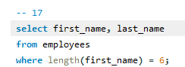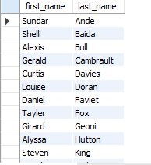
18. From the following table, write a query to find out which employees joined in January. Return
complete information about the employees.
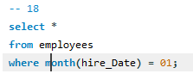
19. From the following table, write a query to separate the names of employees and their managers by the string 'works for'.
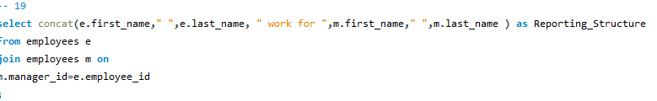
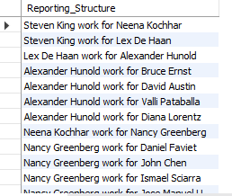
20. From the following table, write a query to find those employees whose designation is ‘CLERK’. Return complete information about the employees.
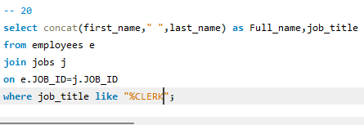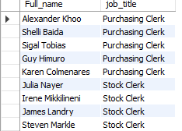
21. From the following table, write a query to identify employees with more than 27 years of experience. Return complete information about the employees.
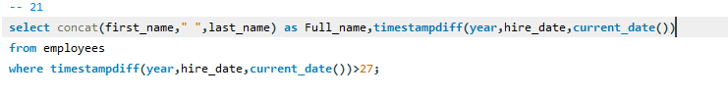
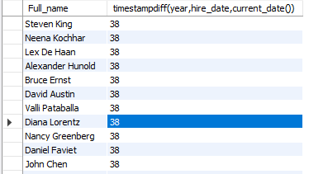
22. From the following table, write a query to find those employees whose salaries are less than 3500. Return complete information about the employees.
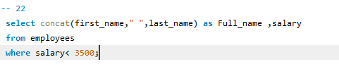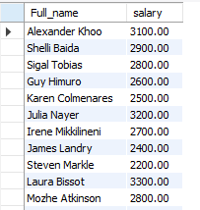
23. From the following table, write a query to find the employee whose designation is ‘ANALYST’. Return employee name, job name, and salary.
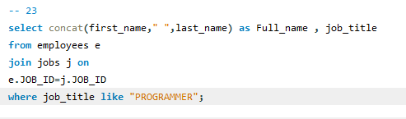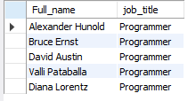
24. From the following table, write a query to identify those employees who joined the company in 1991. Return complete information about the employees.
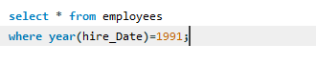
25. From the following table, write a query to find those employees who joined before 1st April 1991. Return employee ID, employee name, hire date, and salary.
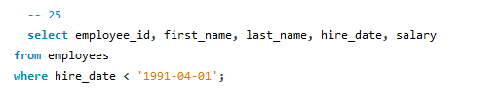
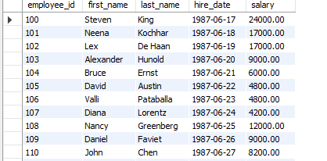
26. From the following table, write a query to identify the employees who do not report to a manager. Return employee name, job name.
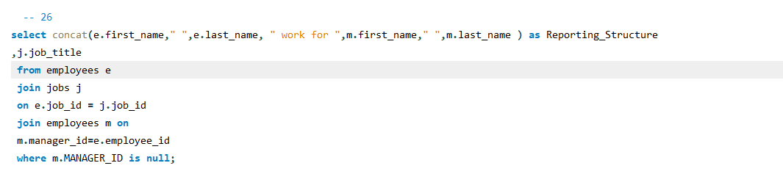
27. From the following table, write a query to find the employees who joined on the 1st of May 1991. Return complete information about the employees.
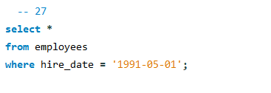
28. From the following table, write a query to identify the experience of the employees who work under the manager whose ID number is 68319. Return employee ID, employee name, salary, and experience.
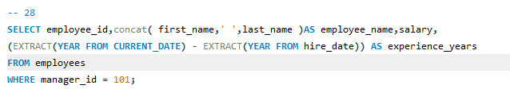
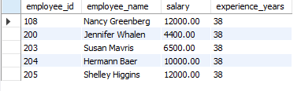
29. From the following table, write a query to find out which employees earn more than 100 per day as a salary. Return employee ID, employee name, salary, and experience.
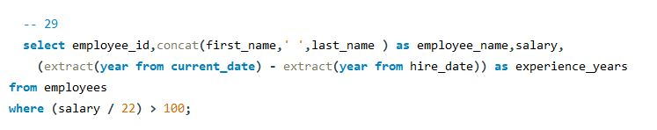
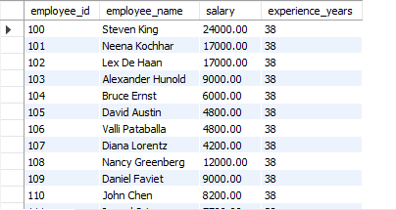
30. From the following table, write a query to identify those employees who retired after 31-Dec-99, completing eight years of service. Return employee name.
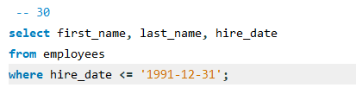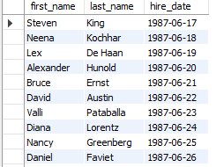
31. From the following table, write a query to identify the employees whose salaries are odd. Return complete information about the employees.
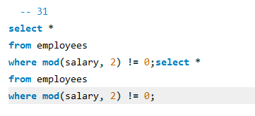
32. From the following table, write a query to identify employees whose salaries contain only three digits. Return complete information about the employees.
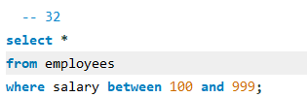
33. From the following table, write a query to find those employees who joined in the month of APRIL. Return complete information about the employees.
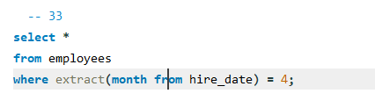
34. From the following table, write a query to find out which employees joined the company before the 19th of the month. Return complete information about the employees.
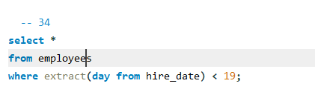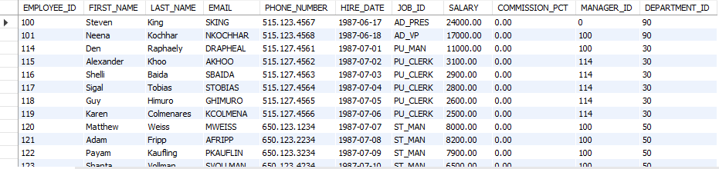
35. From the following table, write a query to identify those employees who have been working as a SALESMAN and the month portion of the experience is more than 10. Return complete information about the employees.
